Parish Councillors are duly summoned to attend a Briercliffe with Extwistle Annual Parish meeting to be held Thursday 14th May 2026 at 7:30pm at the Community Centre, Jubilee Street, Briercliffe.
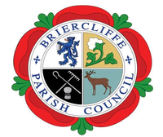
Members of the public are invited to attend.

BRIERCLIFFE WITH EXTWISTLE PARISH COUNCIL
ANNUAL PARISH MEETING
Thursday 14th May 2026 7:30pm

Business:
- Welcome
- Apologies for absence
- Acceptance of Office and Declaration of Pecuniary Interests and Complete Register of Interest Forms
- To confirm or otherwise the minutes of the last Annual Parish Meeting on Thursday 8th May 2025
- Chair’s Report for the past year.
- Finance Report
- To approve the date for the next Annual Parish meeting to be held Thursday 6th May 2027
Cllr Roger Frost
Chair

